Common Source Amplifier Configurations
There are many possible design configurations for a common source (CS) amplifier. The key design choices revolve around what you use as the drain load and biasing network. Here's a full breakdown:

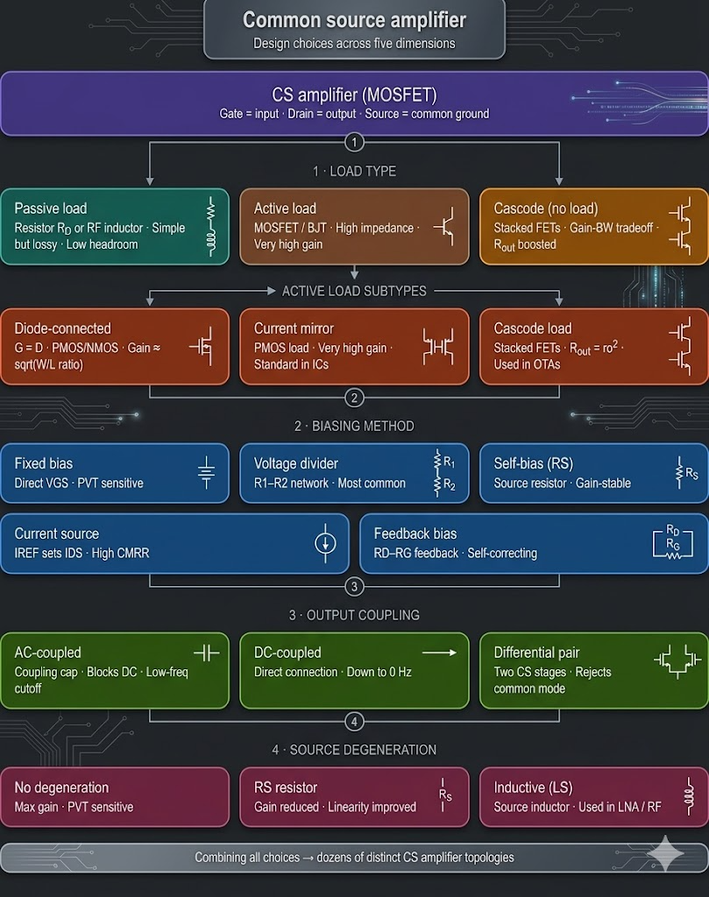
What is Active Load?
In MOSFET amplifier circuits, instead of a passive resistor, the active component like a MOSFET or MOSFET circuit (Current Mirror) is used to increase the gain of the amplifier. This active component or the active circuit is known as the Active Load.
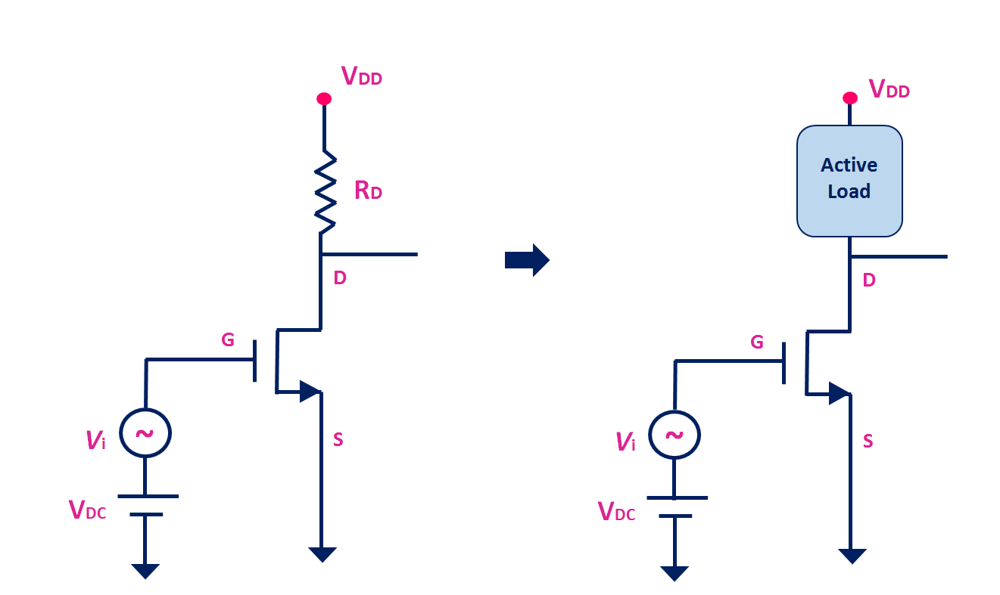
Fig. 1 MOSFET Amplifier with Active Load
Why is Active-Load used in the circuit design?
The Active Load is usually used in the integrated circuits where the size and power consumption are major constrain. Also, in the integrated circuits, fabricating a resistor requires a lot of space. And therefore, instead of a resistor, the active load is used. The active load also helps in increasing the voltage gain of the amplifier. To understand this point, let’s take the example of a simple common source amplifier with the passive load.
The gain of the common source amplifier is
$$\left|Av\right|=gm*\left(R_{D}∥r_{0}\right) \text{where }{\text{r}}_{\text{0}}\text{ is} output resistance$$
$$If r_{0}≫R_{D} then \left|A_{v}\right|≈gm*R_{D}$$

To increase the gain, either R_{D} or gm needs to be increased. But as R_{D} increases, the voltage drop across R_{D} also increases and hence, the available voltage at the drain terminal reduces. At one stage, the MOSFET may come output of the saturation.

Similarly, by increasing the drain current I_{D}, the transconductance (gm) can be increased. But as the drain current increases, the power dissipation in the circuit increases. Also, with the increase in the drain current, the voltage drops across the drain resistor will increase. And at one point, MOSFET may come out of the saturation.

Of course, by increasing the power supply voltage, the MOSFET can be kept in the saturation region, and it is possible to increase the gain by some extent. But that is not an option in the modern integrated circuits where the supply voltage range is shrinking day by day. All these problems can be eliminated using the active load.
Feature | Passive (resistor) | Active (MOSFET)
Element type | Non-amplifying, dissipative | Has its own gm, can amplify
Small-signal impedance | Fixed = R_{D} | Very high: r_{o} = 1/λ.I_{D}
DC voltage drop | Large (I_{D}·R_{D}) | Small (V_{DSsat} ≈ 100–200mV)
Gain achievable | Moderate (~10–30) | Very high (~100–1000)
Used in | Discrete, RF, simple stages | All VLSI/IC op-amps, OTAs
Power efficiency | Low | High

